**Report For Runlinc**

**(A case study for Smart Fan Control System)**

By

Afolayan Oluwatimilehin Israel

080-452

FACULTY OF SCIENCE AND TECHNOLOGY

A Project Report submitted to the Faculty of Science and Technology in Fulfilments of the Requirements for the Award of the Degree of Bachelor of Software Engineering of Cavendish University Uganda.

**Supervisor**

Mr. Kumakech

Faculty of Science and Technology, Cavendish University Uganda

**DECLARATION**

I, **AFOLAYAN OLUWATIMILEHIN ISRAEL** do declare to the best of my knowledge, efforts and with honesty that the work presented in this practicum report is my original and genuine information gathered during my internship research and study with STEMSEL. It is therefore not a duplicate of any body’s work and has never been presented to any university or institution of higher learning for any award of degree, diploma and certificate or any other academic qualification.

**Signature …………………………… Date………………………………**

**AFOLAYAN OLUWATIMILEHIN ISRAEL**

**STUDENT NO: 080-452**

## **APPROVAL**

This is to certify that the project work titled “**Smart Fan Control System**” was prepared and submitted by **AFOLAYAN OLUWATIMILEHIN ISRAEL** to the Faculty of Science and Technology and is accepted by the undersigned, meeting the requirements of the award of the bachelor’s degree (BSE) in Software Engineering at Cavendish University Uganda.

**Signature …………………………… Date………………………………**

**Mr. Kumakech**

**University Supervisor**

**DEDICATION**

Firstly, I am dedicating this report to the Almighty God.

Secondly, I am dedicating this report to my Parents and my aunt for their love and care in my academic advancement during my study. Their sacrifices and guidance have shaped me into the person I am today and have inspired me to pursue my dreams. I am grateful for their constant belief in me and for instilling in me the importance of hard work and perseverance. This thesis is a testament to their unwavering love and support, and I dedicate it to them with all my heart.

**EXECUTIVE SUMMARY**

This report provides a detailed account of the Smart Fan Control System project undertaken during my internship at STEMSEL Foundation. The project aimed to create a smart fan control mechanism utilizing IoT technologies, encompassing both manual and voice control functionalities. This initiative allowed me to deepen my understanding of IoT principles, including programming devices, integrating software for seamless communication, and working with hardware components such as sensors, actuators, and microcontrollers.

The Smart Fan Control System project involved designing a web interface using HTML, CSS, and JavaScript to control the fan's speed and power status. By implementing voice control using speech recognition technology, the system allows users to manage the fan hands-free, enhancing convenience and accessibility. This project exemplifies the practical application of IoT in creating smart home solutions, addressing real-world challenges.

Throughout the project, I encountered and overcame various technical challenges, gaining valuable insights into problem-solving and system integration. The hands-on experience enriched my technical skill set and reinforced theoretical knowledge acquired from academic studies. Key lessons learned include the importance of user-friendly design, efficient coding practices, and the integration of multiple technologies to achieve a cohesive system.

In summary, the Smart Fan Control System project was instrumental in enhancing my IoT proficiency and project management skills. This experience has equipped me with the knowledge and confidence to pursue future endeavors in the IT sector, contributing to my career growth and aspirations of managing my own business. The skills and insights gained from this project will be invaluable in tackling future technological challenges and developing innovative solutions.

**Introduction**

The "Smart Fan Control System" project aims to create a versatile interface for controlling a fan through both manual inputs and voice commands. This report provides an in-depth overview of the system's design, implementation, functionality, and potential enhancements.

**Problem Statement**

In modern living environments, there is a growing need for intuitive and accessible interfaces that simplify everyday tasks. This project addresses the demand for a hands-free fan control system that can be operated effortlessly using voice commands. By integrating voice recognition technology with traditional button controls, the system enhances user convenience, especially in situations where manual interaction may not be practical or convenient.

**Background**

Conventional fan controls typically require physical interaction to adjust speed or turn the fan on/off. Voice-controlled systems offer an alternative by leveraging advancements in speech recognition technology to interpret voice commands and provide real-time feedback. This project utilizes HTML, CSS, and JavaScript alongside the Web Speech API to create a responsive and interactive web application that simulates fan control.

**Objectives**

The primary objectives of the Smart Fan Control System project are as follows:

1. **Develop a User-Friendly Control Interface:** Create an intuitive and accessible web-based interface using HTML, CSS, and JavaScript to enable users to control the fan's power status and speed manually.
2. **Implement Voice Control Functionality:** Integrate speech recognition technology to allow hands-free control of the fan, enhancing user convenience and accessibility.
3. **Utilize IoT Technologies:** Apply Internet of Things (IoT) principles to design and develop the system, leveraging the knowledge gained from my internship with STEMSEL Foundation using runlinc.
4. **Integrate Hardware Components:** Effectively incorporate sensors, actuators, and microcontrollers into the system to ensure seamless communication and functionality.
5. **Enhance Problem-Solving Skills:** Address technical challenges encountered during the project, thereby improving problem-solving abilities and technical proficiency.

**Research Scope**

The research scope of the Smart Fan Control System project includes:

1. **Literature Review:** Conduct a comprehensive review of existing smart home technologies and IoT applications, focusing on fan control systems and their components.
2. **System Design:** Develop a detailed design plan for the smart fan control system, including the user interface and hardware integration.
3. **Software Development:** Write and test the code for the web interface and voice control functionality, ensuring compatibility and smooth operation.
4. **Hardware Integration:** Select and integrate appropriate hardware components, such as sensors, actuators, and microcontrollers, based on the requirements of the system.
5. **Testing and Evaluation:** Perform rigorous testing of the system to identify and resolve any issues, ensuring reliability and user satisfaction.
6. **Documentation and Reporting:** Document the entire development process, including design choices, challenges encountered, and solutions implemented. Prepare a comprehensive report summarizing the project outcomes.

By focusing on these objectives and research scope, the Smart Fan Control System project aims to provide a practical and innovative solution for smart home automation, demonstrating the application of IoT technologies and the skills acquired during my internship with STEMSEL Foundation using runlinc.

**Implementation**

1. **HTML and Styling**

* **Structure:** HTML is used to define the layout and structure of the web page, ensuring clarity and functionality.
* **Styling:** CSS styles elements for a visually appealing and user-friendly interface, including animations and layout adjustments.

1. **JavaScript Functionality**

* **Fan Control Functions:** JavaScript functions manage the state of the fan, including turning it on/off and adjusting its speed based on user interactions.
* **Voice Recognition:** The system utilizes the Web Speech API to recognize predefined voice commands such as "turn on," "turn off," "low speed," "medium speed," and "high speed." Upon recognition, corresponding JavaScript functions are invoked to execute the desired actions.
* **Dynamic Updates:** JavaScript dynamically updates the fan's visual representation and status based on user input, ensuring real-time feedback and control.

**User Interface**

Below are the main components:

* The interface includes visual elements such as the fan representation, control buttons (Turn On/Off, Low Speed, Medium Speed, High Speed, Voice Control), and a status display area.
* Buttons provide direct manual control, while voice control initiates and manages voice recognition for seamless interaction.

**Future Enhancement**

Below are the potential future enhancements:

* **Expanded Voice Commands:** Incorporate additional voice command options to broaden functionality and user control.
* **Cross-Browser Compatibility:** Ensure the system works seamlessly across various web browsers and devices to enhance accessibility.
* **Enhanced Security Measures:** Implement authentication mechanisms to secure access and control of the fan system, ensuring user privacy and safety.

**Acknowledgement**

The project leverages open-source technologies such as HTML, CSS, JavaScript, and the Web Speech API. Development primarily occurred in Sublime Text 3, a versatile source code editor known for its robust features and plugin support, facilitating efficient coding and testing.

**Conclusion**

The "Smart Fan Control System" project effectively demonstrates the integration of manual and voice-operated controls using web technologies and APIs. It showcases the practicality of voice recognition in enhancing user accessibility and convenience for home appliance control. The project underscores the synergy between modern web development practices and emerging technologies to address everyday challenges effectively.

**Appendix**

Code Screenshots;

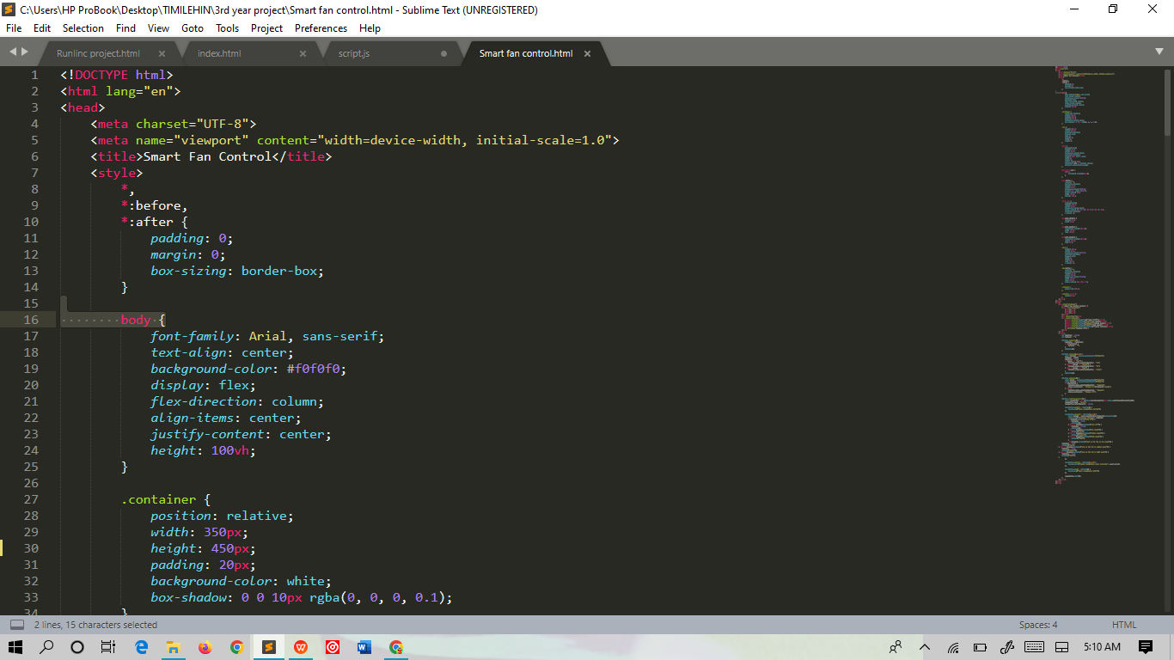

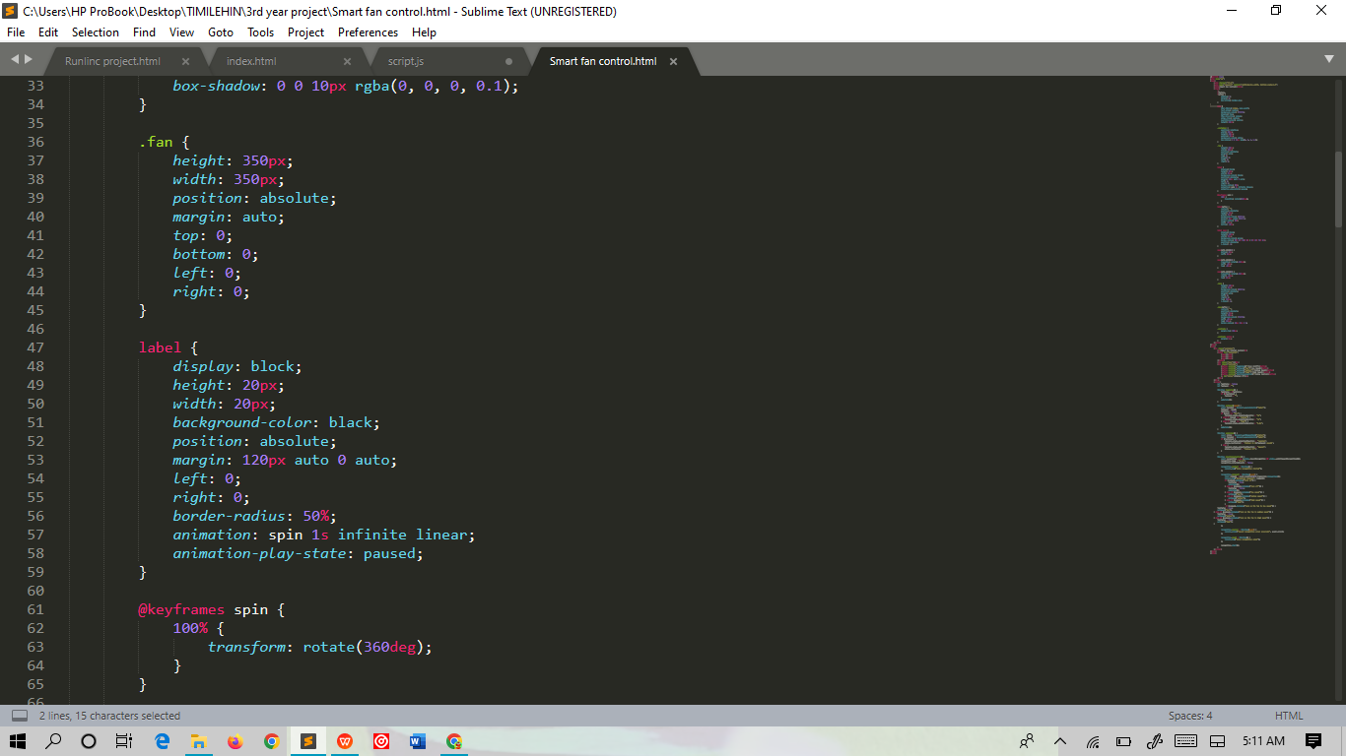

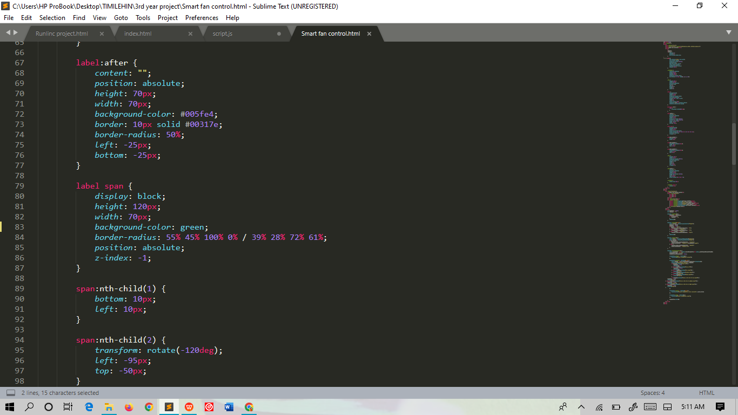

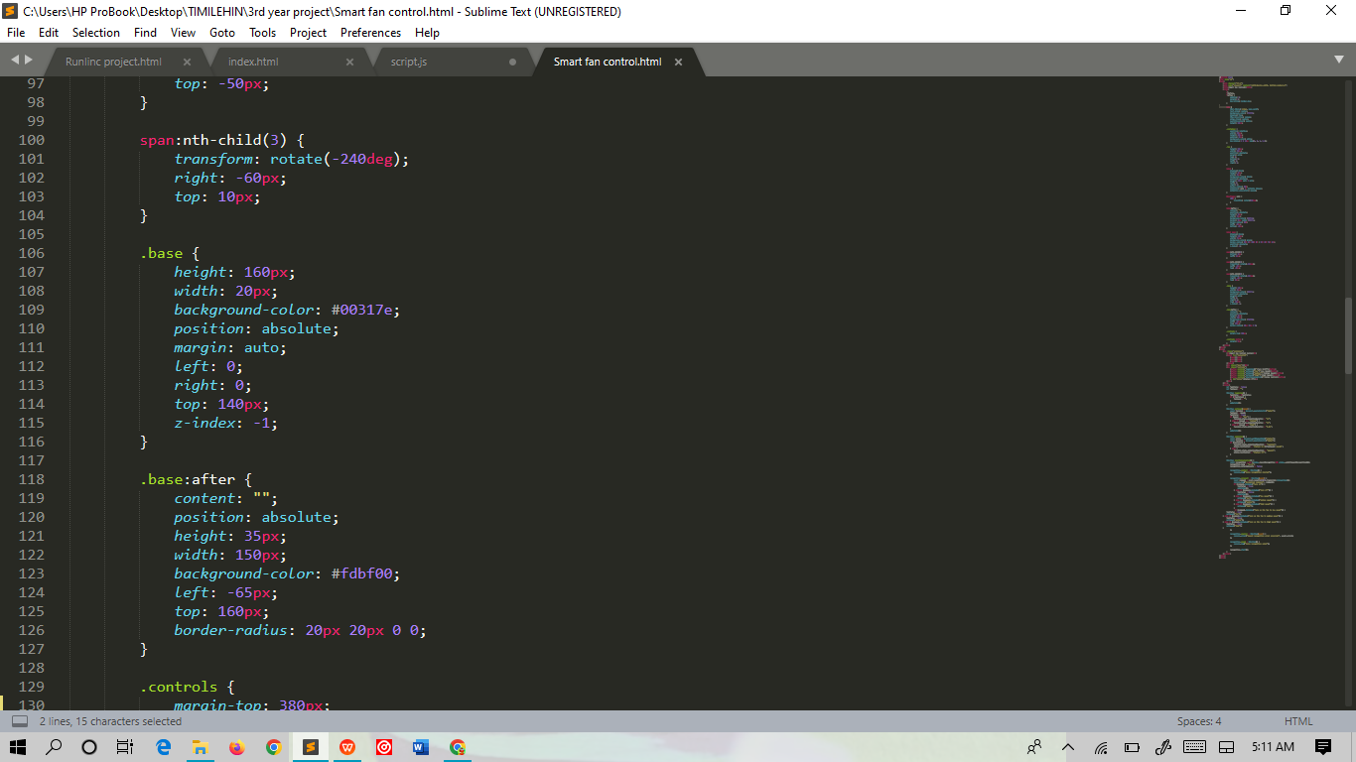

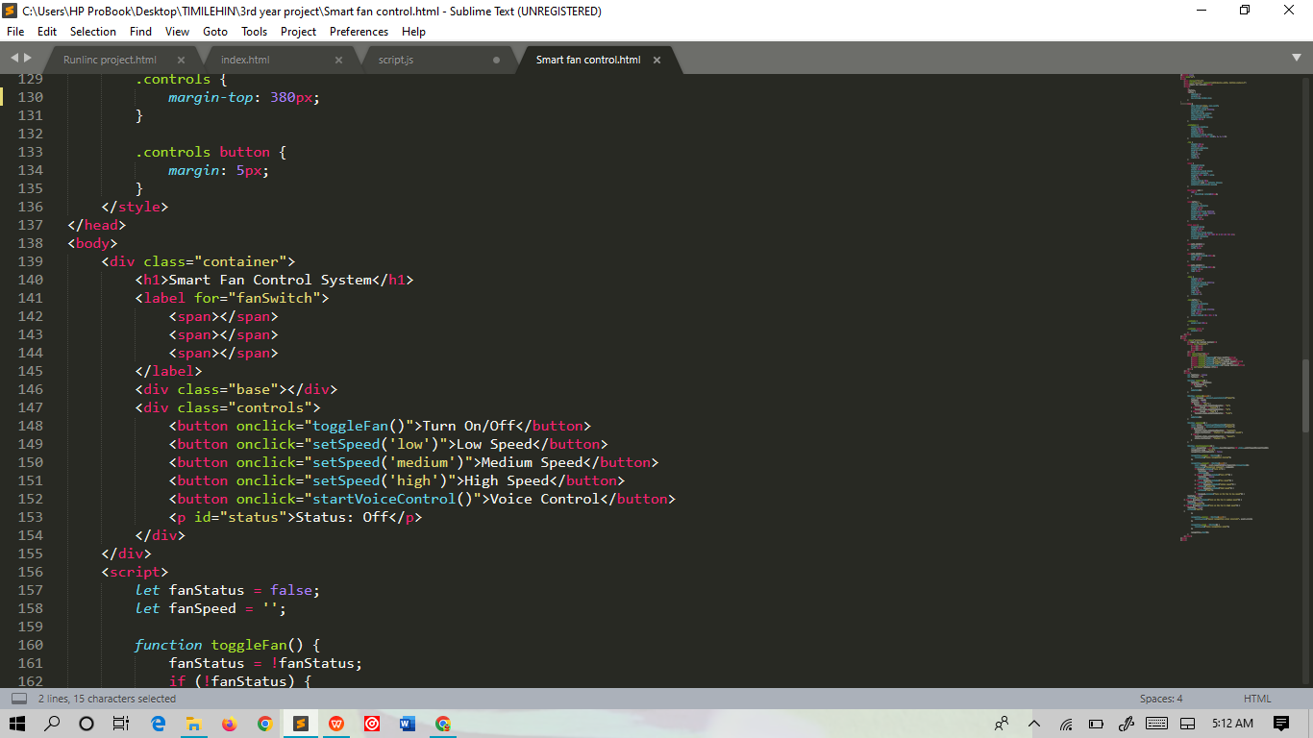

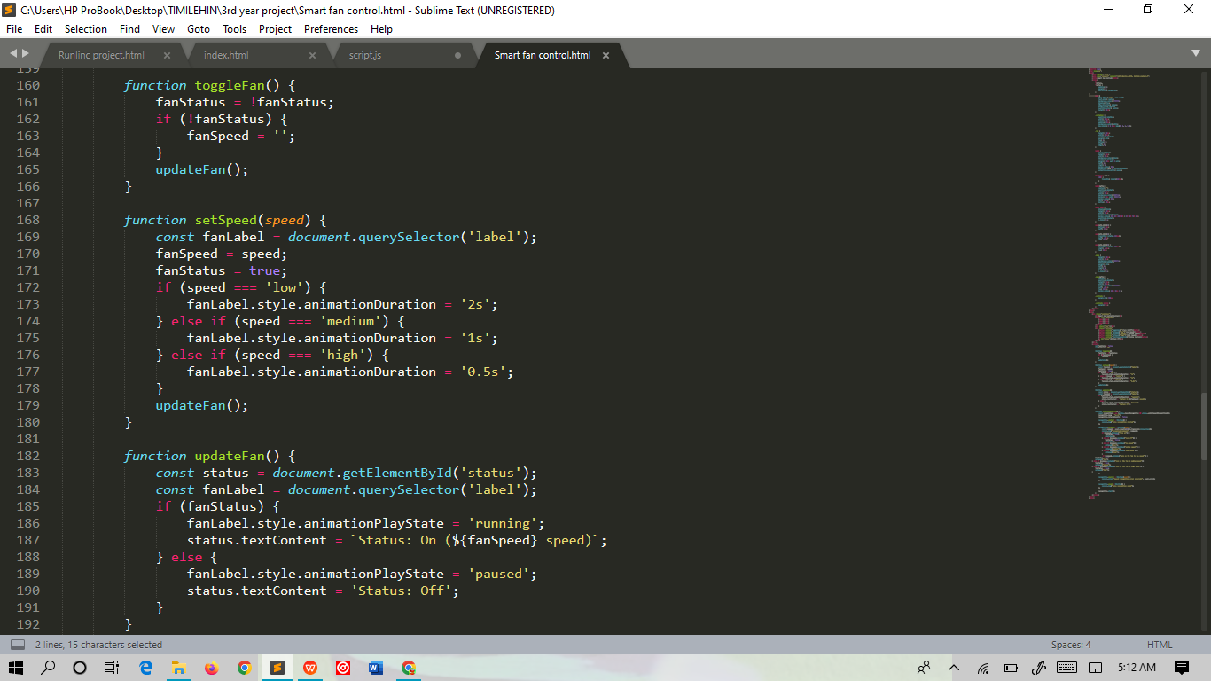

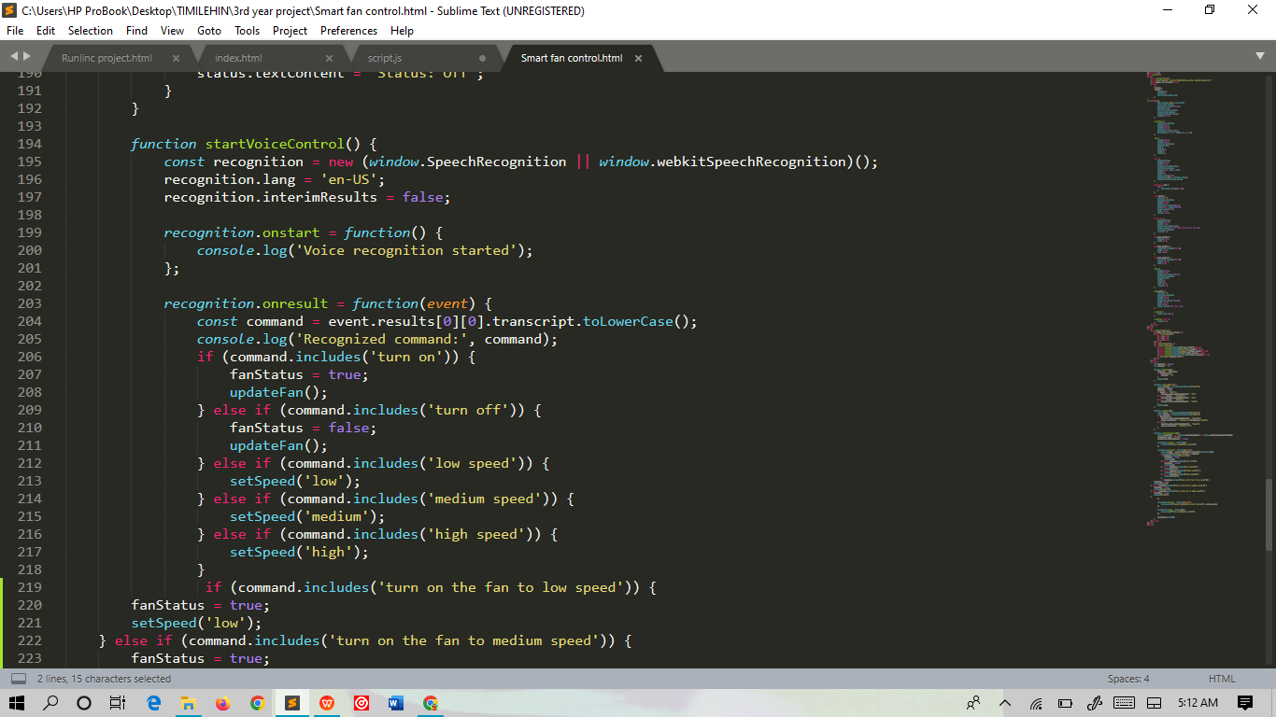

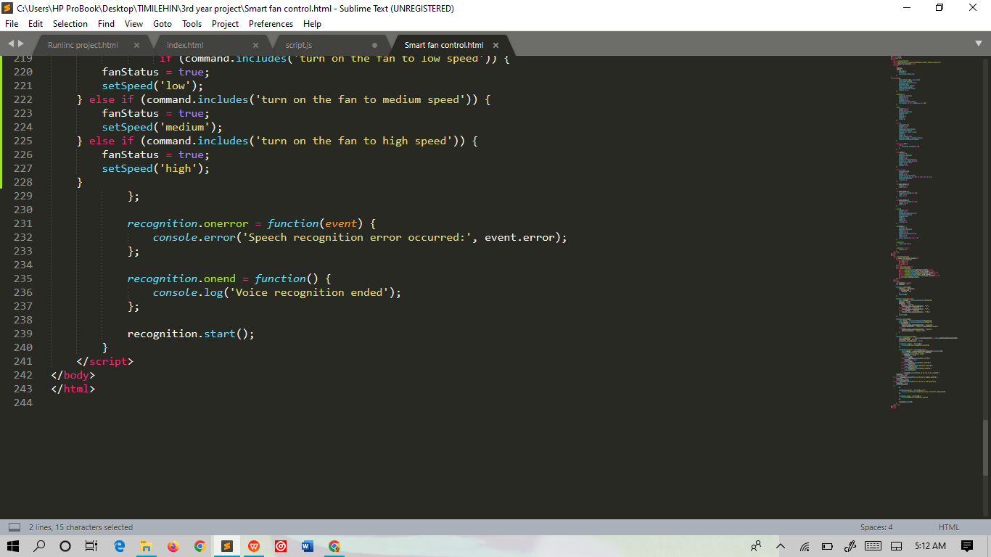

Code Output;

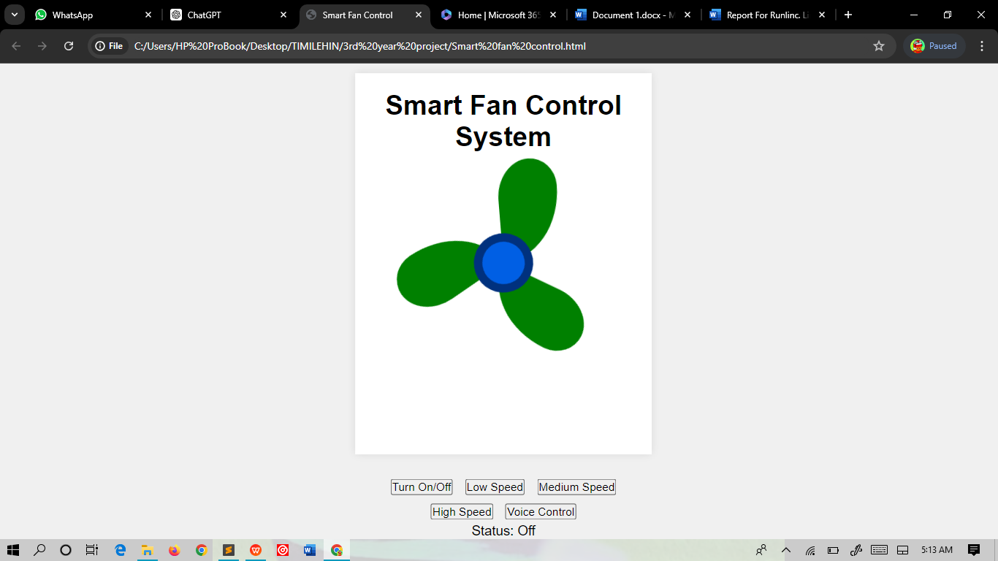

**References**

<https://foundation.stemsel.com/>

http://runlinc.com/online/control.html.

Sublime Text